NFCC Central Programme Office overview

Purpose of report
For information.

Summary
This report sets out how the National Fire Chiefs Council (NFCC) is now managing and delivering projects and programmes through a new organisation called the Central Programme Office. This builds on the programme approach that led to the successful delivery of National Operational Guidance (NOG) for the fire and rescue service.

Recommendation
Fire Commission members are asked to note the new arrangements for managing and delivering programmes and projects by the NFCC Central Programme Office (CPO).
Action
For information.

Contact officer: Lucy Ellender
Position: Adviser, Policy - People
Phone no: 02076643321
Email: Lucy.Ellender@local.gov.uk

NFCC Central Programme Office overview
Background
- Fire and Rescue Authorities across the UK and the Home Office agreed to fund the NOG programme. After six years, the result is the creation of a suite of 21 pieces of guidance, 22 training specifications and 27 scenarios covering the whole range of operational activity. The programme completed its work in March 2018.

- During the last year of the programme, the NFCC explored options for maintaining the guidance and using this programme management expertise in other areas of fire and rescue services business. In particular, this work looked at how to take a programmatic approach to delivering the objectives of the NFCC as set out in its strategy. The result is the creation of the Central Programme Office launched on 1 April 2018.

About the CPO
- The CPO provides programme, project and benefits management services to the fire and rescue sector. It forms one of the three hubs supporting the delivery of the National Fire Chiefs Council's strategy. The other two hubs focus on national resilience (Merseyside FRS) and support services (WMFS).

- In a new departure for the fire and rescue service, the CPO will use portfolio management techniques to assist in the selection, prioritisation, control and delivery of programmes and projects in line with its strategic objectives and capacity to deliver.

- The CPO is located at London Fire Brigade's HQ and many members of the NOG Programme team now work for it. Like NOG, the CPO will be a place where staff from fire and rescue services are encouraged to work on secondment, gaining valuable experience of working at a national level.

- In order for the CPO to be effective, it will work in the following way:

    - Develop its work through collaborative programmes and projects that draw on the best available expertise.

    - Maintain what has been produced and respond to change to ensure it remains of the highest quality and is accessible to all who need to use it.

    - Demonstrate the effectiveness of all products and take proactive action to encourage their use.

    - Support the involvement of all stakeholders in making decisions about our work and assure them about the quality of the whole portfolio.
Deliverables
- From the start, the CPO will provide a home for the continued maintenance of NOG. It will be a business as usual activity and include the continued development of national operational learning.

- There will be a new system of regular review meaning that every piece of guidance will be considered to see whether it needs to be updated. There will also be key influencers such as the outcome of inspections. Taking both a proactive and reactive approach like this will ensure that the guidance and the associated training specifications keep pace with change over time.

- The work of the CPO will focus initially on three areas of the NFCC’s strategy:

    - Community Risk

    - People

    - Digital

- CFO Phil Loach from West Midlands Fire Service leads the Community Risk Programme. Risk management, like many areas of fire and rescue service performance, is difficult to benchmark and compare performance. This programme will produce, as one of its outputs, a clear definition of risk that would allow communities to hold the performance of their fire and rescue service to account.

- The second programme of work is focused on the People Programme, led by the Chief Executive of Kent Fire and Rescue Service, Ann Millington. It will cover areas like firefighter recruitment, mental health and wellbeing.

- Of the three programmes, the Digital programme is the least developed. It will look at readying the service for a digital future optimizing the opportunities from developments such as smart buildings, driverless vehicles and robotics.
Professional Standards
- An element of the Government’s fire reform programme was the creation of professional standards. The Minister for Policing and the Fire Service is currently considering a proposal by the sector-led Professional Standards Project Board to establish a delivery mechanism to produce these standards which involves the CPO. A decision is expected imminently and details will be shared as soon as possible.

Governance
- The NFCC Council will provide strategic direction to the CPO, ensuring that the development and delivery of products from the CPO are in line with the NFCC strategy.

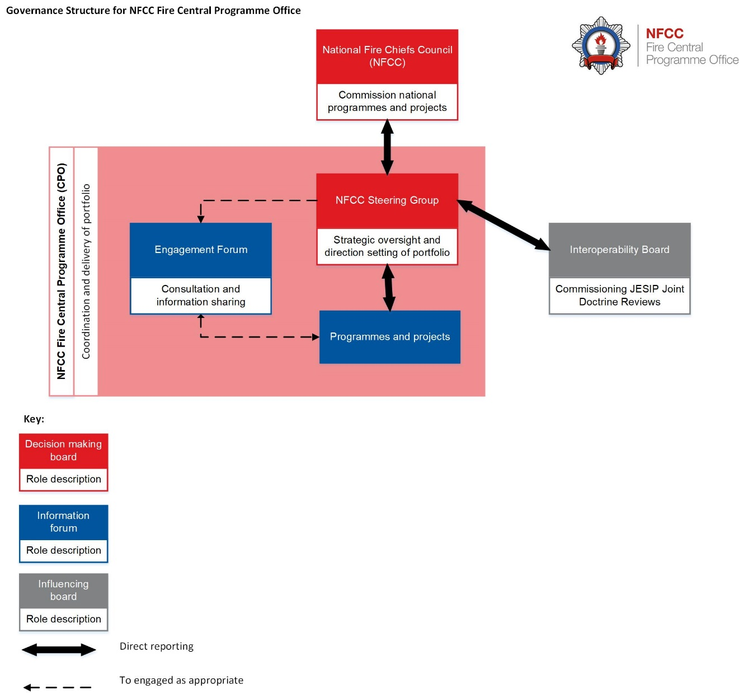

Stakeholder engagement
- The CPO work programme will rely on continued engagement and consultation, as appropriate, from across the sector. This collaborative approach worked well for NOG and will continue under CPO. For each project within the proposed programmes, the stakeholders that need to be involved will be identified from both inside and outside of the sector.

- In addition, a sector wide Engagement Forum (EF) will be created. The EF will be chaired by the NFCC and will not have a decision-making role. Its purpose is to support the CPO by providing a wide range of views about the programmes. Representative bodies, fire sector organisations and appropriate private sector organisations will all be invited to become members of the EF.

Implications for Wales
- The work of the CPO applies to Wales as well as Scotland and Northern Ireland.

Financial implication

- There are no new burdens to Fire and Rescue Authorities as a result of this work as existing financial arrangements for the development of guidance still apply.

Next steps
- The first six months of the CPO will necessarily involve setting up new programmes and the arrangements needed to make them successful, including any involvement in professional standards

- Updates on the work of the programme will be made available as required to future meetings of the Commission.

